*Q3)*

Find the DOF using Grubler’s formula

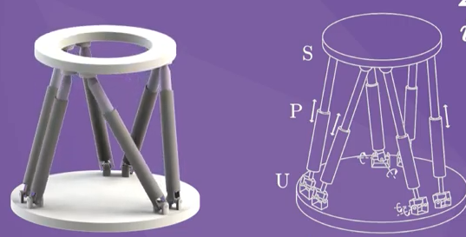

N = 14 links #with top/bottom grounds

6 spherical joints with 3 DOF

6 prismatic joints with 1 DOF

6 universal joints with 2 DOF

M = 6

DOF = 6\*(14-1-18) + 6(1) + 6(2) + 6(3) = 6